**Cannon Hill ELC 2022 Calendar of Events!**



♥ 26th Australia Day

♥ 24th First Day in new rooms, First day of Term 1



♥ 1st Chinese New Year, Year of the Tiger

♥ 6th Waitangi Day

♥11th Green and Gold dress up day

♥ 14th Valentine’s Day

♥ 2nd Dr Seuss Day

♥ 6th-7th Clean Up Australia Day

♥ 16th Funky Hair Day - Shave for a cure, raising money for blood cancer. Gold coin donation

♥ 17th St Patrick’s Day celebrations – Wear green

♥ 15th-21st Harmony week

♥ 18th Holi

♥ 21st: Harmony Day

♥ 22nd Harmony Day Banquet

♥ 25th Epilepsy Awareness Day (Purple Day)

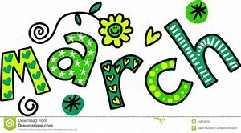

♥ 1st- End of term 1

♥ 6th-16th Nature Play Week

♥ 14th Easter Bonnet Parade

♥ 15th Good Friday Public Holiday Day

♥ 18th Easter Monday Public Holiday Day

♥ 19th Term 2 begins

♥ 22nd-Earth Day

♥ 25th ANZAC Public Holiday Day

♥ 28th R U OK? Day

♥ 29th International Dance Day



♥ 2nd Labour Public Holiday Day, QLD

♥ 4th Star Wars Day

♥ 3rd-6th Mother’s Day Stall open

♥ 6th Mother’s Day Morning Tea Mother’s Day raffle drawn

♥ 8th Mother’s Day

♥ 15th International Day of Families

♥ 17th-19th School Photos

♥ 19th Australia’s Biggest Morning Tea

♥ 25th National simultaneous story time 2022

♥26th Sorry Day

26th – Sorry Day

27th May-3rd June-Reconcilliation week

30th – Aboriginal Culture show $6 per child 10AM



♥ 8th State of Origin 1-wear your colours

♥ 17th Centre Fiesta (Disco after hours)

♥ 20th-30th- Parent Teacher interviews

♥ 21st International Day of Yoga

♥ 24th Term 2 ends

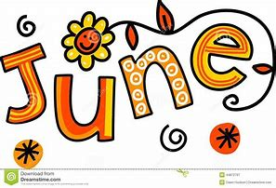

♥ 4th Winter pie drive fundraiser begins

♥3rd-10th-NAIDOC Week- Theme- Get Up! Stand Up! Show Up!

♥ 11th- Term 3 begins

♥ 13th State of Origin 3 Wear colours

♥ 22nd National Pyjama Day, Wear your PJs

♥ 29th Trivia Night

♥ 30th School Tree Day

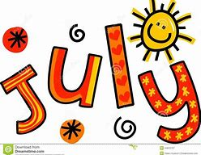



♥ 1st-30th-Share the Dignity-Dignity drive

♥ 5th– Jeans for Gene’s Day

♥ 10th – Ekka Show Day (Public Holiday)

♥ 13th-21st-National Science Week

♥ 18th-Ocean Life workshop

♥ 20st-26th– Book Week/ Dreaming with eyes open

♥ 24th: Book Week Parade

♥ 29th -31st Father’s Day stall open

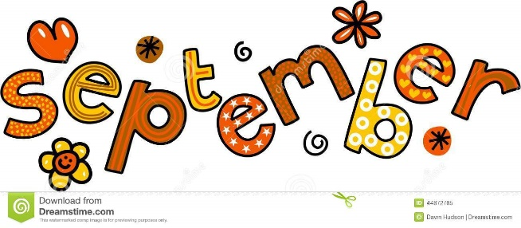

♥ 1st -2nd Father’s Day stall open

♥2nd: Father’s Day Afternoon /raffle drawn

♥4th-Father’s Day

♥ 6th-Superhero Day, supporting Muscular dystrophy

♥ 7th-Early Childhood Educators’ Day

♥ 12th Grandparents Day afternoon tea

♥ 16th – Term 3 ends

♥ 19th-Talk Like a Pirate Day (dress up)

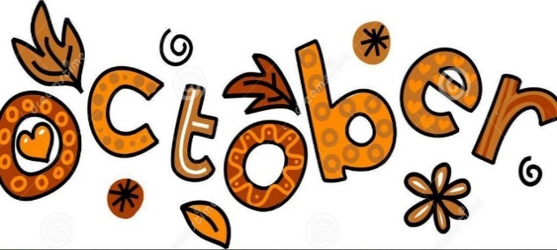

♥ 3rd Queens Birthday public holiday

♥ 4th Term 4 begins

♥ 4th 10th: World Space week

♥ 21st Loud Shirt Day

♥ 24th Diwali

♥ 31st Halloween/ Dress up day!

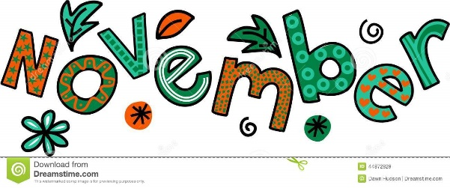

♥ 1st-25th Share the Dignity- “It’s in the Bag” collections

♥ 11th – Remembrance Day

♥ 18th - Date Night

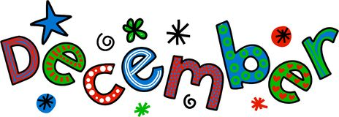

♥ 1st – Preschool Graduation

♥ 8th Christmas Party

♥ 9th – Term 4 Ends

♥ 24th – Christmas Eve

♥ 25th – Christmas Day

♥ 26th – Boxing Day (Public Holiday)

♥ 27th - Public Holiday

31st – New Year’s Eve